|  |  |  |  |
| --- | --- | --- | --- |
| **Lecturer:** | *(Date)* | **Approved by:** | *(Date)* |
| *(Signature & Fullname)*  ***SOLUTION*** | | *(Signature, Position & Fullname)* | |

|  |  |  |  |  |  |  |  |  |
| --- | --- | --- | --- | --- | --- | --- | --- | --- |
|   **UNIVERSITY OF TECHNOLOGY – VNUHCM**  **FACULTY OF COMP. SCI. & ENG.** | | **FINAL EXAM** | | **Semester/Academic year** | | | **1** | **2020-2021** |
| **Date** | | | **26/01/2021** | |
| **Course title** | **Electrical Electronic Circuits** | | | | | |
| **Course ID** | **CO2037** | | | | | |
| **Duration** | **80 mins.** | | **Question sheet code** | **2601** | | |
| ***Notes:*** | *- ONLY ONE A4 paper with your own notes is allowed.*  *- Can use pencils for drawing diagrams*  *- Choose one correct answer of each multichoice question*  ***- Submit the question sheet together with the answer sheet*** | | | | | | | |

1. **MULTIPLE CHOICE: (30 points)**

|  |  |  |  |  |  |  |  |  |  |
| --- | --- | --- | --- | --- | --- | --- | --- | --- | --- |
| **Q. 1**  **D** | **Q. 2**  **B** | **Q. 3**  **A** | **Q. 4**  **C** | **Q. 5**  **A** | **Q. 6**  **A** | **Q. 7**  **D** | **Q. 8**  **B** | **Q. 9**  **B** | **Q. 10**  **C** |
| **Q. 11**  **A** | **Q. 12**  **B** | **Q. 13**  **B** | **Q. 14**  **C** | **Q. 15**  **A** |  |  |  |  |  |

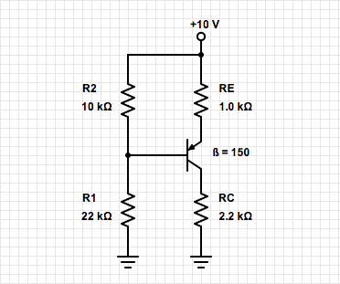

**WRITTEN: (70 points).**

**Question 1. (L.O.4) (30 points)** Consider the circuit of a Voltage-Divider Biased PNP Transistor and then determine ____.

* VB = 6.875V (10 points) (10 * R1/ R1 + R2)
* IE = 2.425mA (10 points) ( 10 – 0.7 – VB/RE)
* VEC = 2.24V (10 points) (10 – IE*(RE+RC))

**Question 2. (L.O.4**) **(20 points)** Consider a negative feedback Op-Amp circuit

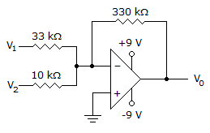

What is the voltage of the negative pin of the Op-Amp (5 points)

**Solution**: V- = 0V

If V1 = -0.2V and V2 = 0V, what is the value of V0? (10 points)

**Solution**: V0 /330K = (0-V1)/33K

* **V0 = 2V**

If V1 = -0.2V and V2 = -0.1V, what is the value of V0? (5 points)

**Solution**: V0 = 2 + 3.3 = 5.3V

**Question 3. (L.O.4**) **(20 points)** Consider the following circuit and the determine ____.

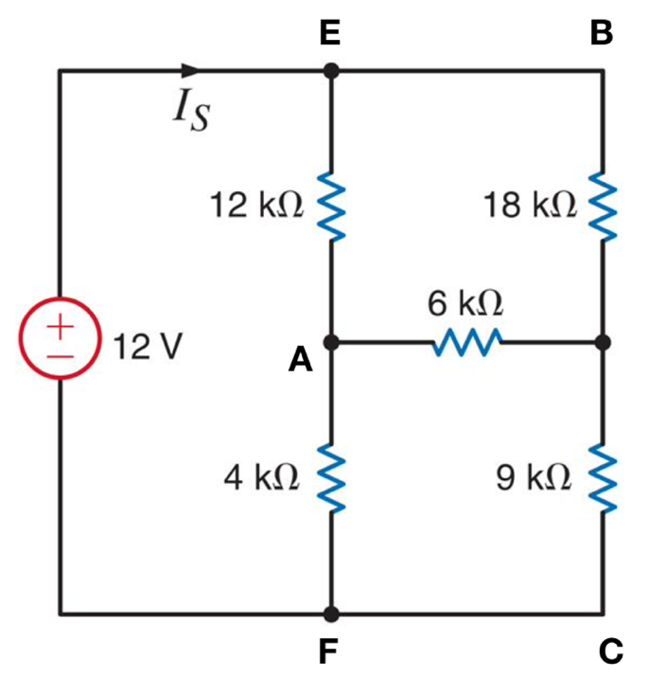

REF = 10 ohms (15 points)

IS = 1.2 A (5 points)

Hints: use Delta-Wye Conversion to find the equipvalent circuit.

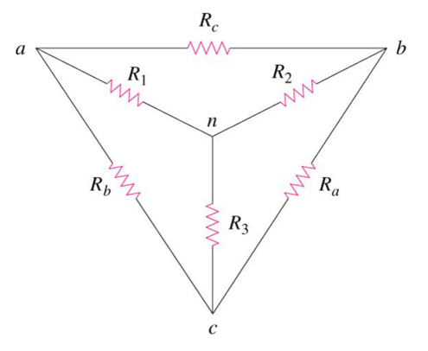

Where

$R_{a}=\frac{R_{1}R_{2}+R_{2}R_{3}+R_{3}R_{1}}{R_{1}}$ $R_{b}=\frac{R_{1}R_{2}+R_{2}R_{3}+R_{3}R_{1}}{R_{2}}$ $R_{c}=\frac{R_{1}R_{2}+R_{2}R_{3}+R_{3}R_{1}}{R_{3}}$

and

$R_{1}=\frac{R_{b}R_{c}}{R_{a}+R_{b}+R_{c}}$ $R_{2}=\frac{R_{c}R_{a}}{R_{a}+R_{b}+R_{c}}$ $R_{3}=\frac{R_{a}R_{b}}{R_{a}+R_{b}+R_{c}}$

––– END –––

Stu.ID: Stu. Fullname: **SOLUTION**